Tools for Math Review Sheet
y = (slope)x + (y-intercept)

Area of square = (length of side)²
Circumference of circle of radius r = 2πr
Area circle of radius r = πr²
Area triangle = ½(base × height)
Surface area cube = 6(length side)²
Volume cube = (length side)³
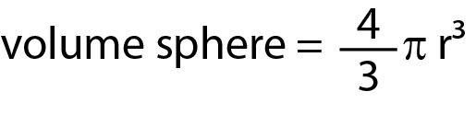

a^{x} • a^{y} = a^{x+y}
a^{x} ÷ a^{y} = a^{x-y}
(a^{x})^{y} = a^{x•y}
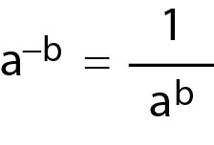

The logarithm of a number is the exponent by which a fixed number, the base, has to be raised to produce that number. The log base a of a number y is the power of a that yields y.
log_{a} y = log_{a} a^{x} = x e.g log₁₀ 1000 = log₁₀ 10³ = 3
log₁₀ is commonly described as just log.
Log_{e} is commonly described as ln.
e = 2.71828182845904523536028747135266249775724709369995...
log_{a} a = 1 e.g. log 10 = log 10¹ = 1 or ln e = ln e¹ = 1
log_{a} (b•c) = log_{a} b + log_{a}c
log_{a} (b÷c) = log_{a} b − log_{a}c
log_{a} b^{c} = c log_{a} b e.g. ln 2⁻³ = -3 ln 2

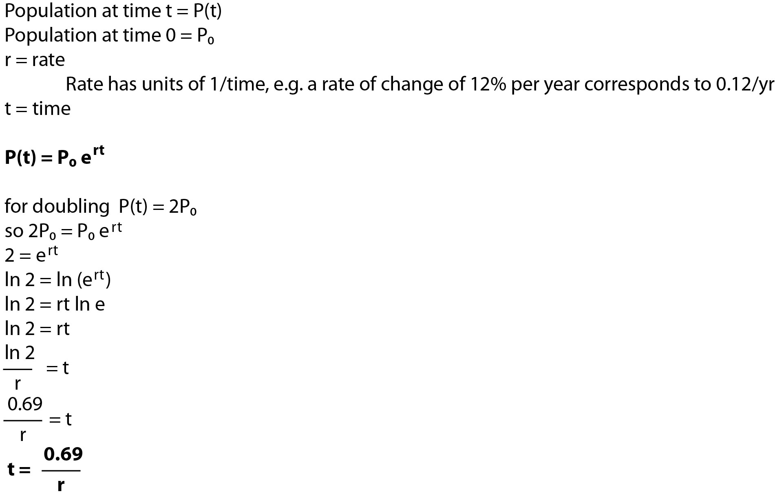

A radian is the ratio between the length of an arc and its radius. It is normally described in terms of pi (π) and as a unitless quantity.
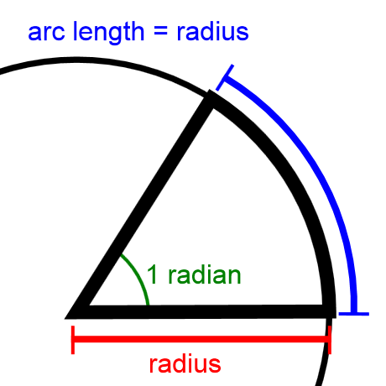
A complete circle has an arc length of 2πr (its circumference), so a complete circle is 2π radians.
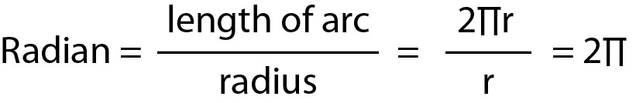
A complete circle is 360°, 360° is 2π radians, leading to the following conversion factor.


